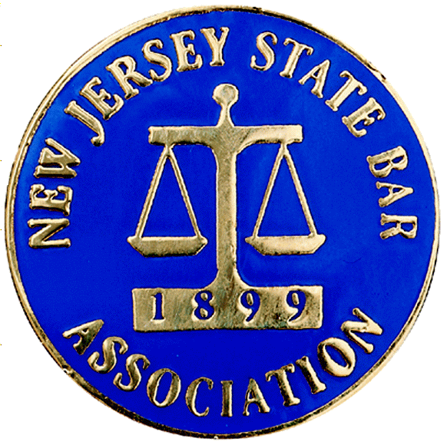

New Jersey State Bar Association
Nomination Petition

In accordance with the bylaws of the New Jersey State Bar Association, we the undersigned general members of the Association (1) acknowledge John Keefe has been nominated by the Association’s Nominating Committee for a one-year term as Secretary_ of the Association, and (2) do hereby nominate Bonnie Blume Goldsamt by petition for the same one-year term as Secretary of the Association.

Signature | Print Name | E-Mail
1.
2.
3.
4.
5.
6.
7.
8.
9.
10.
11
12.
13.
14.
15.
16.
17.
18.
19.
20.

