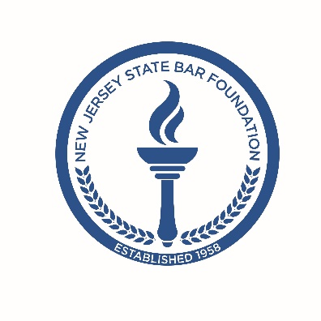

NEW JERSEY STATE BAR FOUNDATION
Solicits Candidates for Board of Trustees

Deadline for submitting Questionnaire: Friday, May 22, 2020

The New Jersey State Bar Foundation’s Nominating Committee is inviting New Jersey State Bar Association members and non-lawyers to submit their names for consideration for a position on the Foundation’s Board of Trustees. Each nominated Trustee will serve for a one-year term beginning on June 17, 2020. Trustees are eligible to serve a maximum of eight terms on the Board.

The New Jersey State Bar Foundation, the charitable and educational arm of the New Jersey State Bar Association, provides a wide variety of free, law-related programs and services to the public. The Foundation’s mission is to:

- Foster an increased awareness, appreciation and knowledge of law and the legal system among New Jersey residents;

Serve as the statewide resource for law-related education for the public;

- Provide opportunities for lawyers to serve the public through the Foundation's programs; and

- Foster professionalism and pride in the profession of law through public service.

With funding from the IOLTA Fund of the Bar of New Jersey, as well as generous support from the legal community, the Foundation is able to reach thousands of New Jersey residents each year.

Interested candidates should complete a Questionnaire that is available by contacting Mary Jean Barnes, Director of Administration and Grants Programs, at mjbarnes@njsbf.org.

